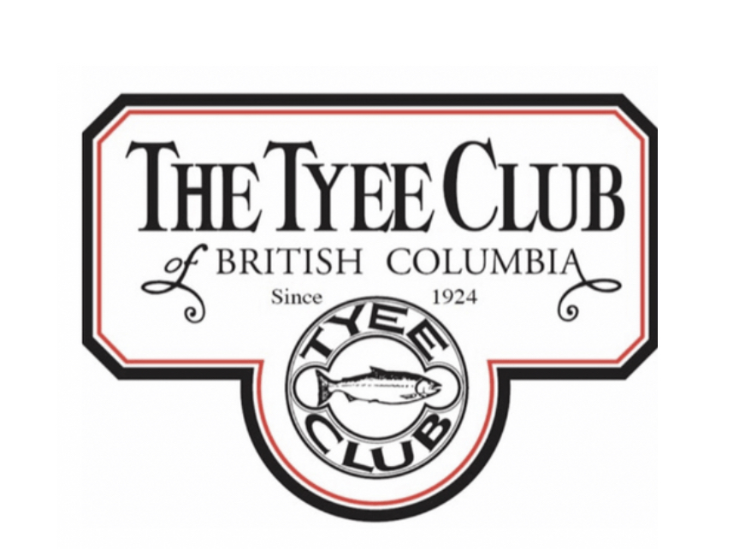
Periodically the Tyee Club and its fishery participants get taken to task for retaining some of the larger chinook salmon that return to the Campbell/Quinsam watershed. Given that these comments arise on a variety of social media forums without any editorial oversight they tend to sensationalize certain aspects of this pursuit, and any kind of rebuttal inevitably leads to an endless chain of vitriolic commentary. It’s a curious thing that nobody ever seems to get upset enough to publish rants decrying all the powerboats that congregate outside the border of the Campbell River Special Management Zone (CRSMZ) in places, fishing for exactly the same fish but with all the usual allowances of the modern recreational fishery – powered boats with sophisticated electronics, commonly using downrigger assisted fishing gear and use of bait with multiple and/or multi-point hooks. As the Tyee Club approaches its centenary as a recreational fishing organization, this statement is an attempt to provide some context to the Tyee Club fishery early in the 21st century.

Although undeniably the focus of this fishery has always been to catch and retain the largest chinook possible, compared to most other tidal water recreational fisheries for salmon the self-imposed regulations of the Tyee Club have also sought to provide the greatest chance to these fish to remain uncaught. The mandatory use of an artificial lure with a single (now barbless) hook for non-feeding fish in combination with constraints on line strength and a prohibition on the use of either electronic fish detection devices or powered boats while fishing ensures that the great majority of these chinook salmon will remain uncaught or, if hooked, a greater likelihood to get away. And in keeping with the evolving ethics of the recreational fishery, the Tyee Club has a catch and release category for those members so inclined, and supports the ethical, safe and healthy release of fish. The Club discourages taking fish out of the water for photographs and measurements, the health and strength of the fish after release being of the highest importance.

The Campbell River Special Management Zone has been in effect for approximately 20 years and this unique regulation package was a management response to sustaining opportunity to be able to fish for these large chinooks from both powered and rowboats. Several successive years of low abundance in combination with “business as usual” recreational fishery regulations outside the immediate Tyee Pool area resulted in an unsustainable harvest rate on this chinook stock, obliging DFO to close the fishery early. Without the development of the CRSMZ it is doubtful that the Tyee Club would exist now, a loss to the culture of this town, and neither would other anglers have been able to continue fishing along the Campbell River waterfront.

In addition to this conservative engagement in its fishery, the Tyee Club has long understood the need to maximize the productivity of the river environment to sustain this special chinook stock. Over the decades, members of the Tyee Club community have provided leadership in mitigating the many woes that have been inflicted on the Campbell River watershed, all of which have had a far greater impact on this chinook stock than the highly regulated fishery that occurs along the waterfront adjacent to the estuary. Mine pollution, loss of gravel, and water flow management are just a few of the issues that members of the Tyee Club, with the full support of the Club itself, have actively addressed in a concerted effort to restore the productivity of the river. More recently, the Tyee Club in partnership with others has led an annual drive to remove all manner of inorganic debris from the estuary, with automobile tires alone numbering in the hundreds. As well, the Tyee Club has been one of the long-term community partners with the Quinsam hatchery in operating one of the chinook smolt net-pen projects each spring which, amongst other things, provides a more predictable and widely dispersed fishing opportunity for anglers of all types along the Campbell River waterfront.

The Tyee Club community has been active in trying to understand the impact of its fishery on the chinook stock returning to the Campbell/Quinsam watershed. To this end, starting in 2015 anglers have been encouraged to donate the heads of chinook salmon caught in the CRSMZ for analysis. As well as externally marked fish (adipose fin-clipped) bearing a coded wire tag (CWT), all hatchery origin chinook are otolith marked with a unique sequence depending on the particular program they originate from (river release from the hatchery, net-pen, lake fry transplant, eyed-egg transplant etc.) and a detailed description of this project can be found on the Club website at www.tyeeclub.org .

Response in the Tyee Club community to this initiative has been strong and virtually all of the heads turned in for analysis have been from anglers participating in the Club fishery. The 293 heads analysed from the 2015 to 2018 seasons (out of a total aggregate return in those years of approximately 28,000 chinooks) demonstrated that about 80% of the catch is from chinooks originating from one of the different hatchery programs and only 17% were five year-olds, likely the largest fish. The information from this study has resulted in the CRSMZ being exempt from the 80 cm maximum size limit for chinook between July 15 and August 31st around the Strait of Georgia, a benefit to all anglers fishing in this area regardless of what platform they are fishing from.

It is sometimes said that fisheries like that of the Tyee Club that target the largest fish are inhibiting the rebuilding of this special stock of chinook salmon because “big fish breed big fish”. This may or may not be true, and currently there’s no scientific certainty around this idea. In order to find out the truth, if possible, in the years 2015 to 2017 Quinsam hatchery in conjunction with DFO science staff conducted a like-size pairing spawning experiment, with each size range (small, medium and large) given a unique otolith mark so that when the surviving fish return to the spawning grounds or hatchery the usual sampling of the adult return will hopefully provide an answer. Given that the first five year-old offspring from this experiment only returned in 2020, it will be a few years before any real signal might become apparent.

As it approaches the centenary of its founding in 1924 the Tyee Club remains committed to doing everything it can, often in partnership with others, to ensure the long-term productivity and survival of this special chinook stock. Despite what the naysayers appear to believe, there’s no credible information to suggest that the Club fishery as practised is in any way prejudicial to this goal, and the CRSMZ management regime maintains a meaningful opportunity for anglers of all kinds (power or row boat or pier based) to catch and keep a large chinook salmon, an opportunity to be valued in the 21st century.

